FOR IMMEDIATE RELEASE
CONTEMPO ANNOUNCES 51ST SEASON:
CONTINUING TO CHAMPION THE BEST IN NEW MUSIC
UNDER NEW ARTISTIC DIRECTOR MARTA PTASZYŃSKA
Focus Includes European Composers and Latest Trends in Intermedia Music
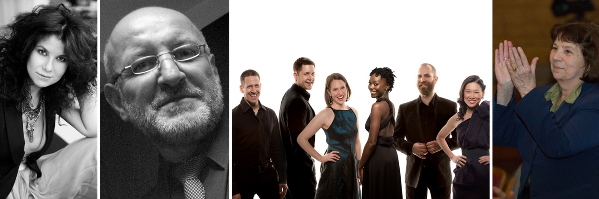
From left, acclaimed vocalist Agata Zubel returns next season in the “Focus on Europe” program; Marek Choloniewski appears as composer and performer in the first set of the “Contempo-Jazz Double Bill” April 16, featuring the cutting-edge trend of intermedia music; eighth blackbird along with Pacifica Quartet again serves as a resident ensemble for Contempo; and Marta Ptaszyńska begins as the collective’s new artistic director.
Photo credits: Zubel/Jackub Pajewski; eighth blackbird/Luke Ratray; Ptaszyńska/Elliot Mandel
CHICAGO, July 28, 2015 — Contempo, the University of Chicago Presents’ renowned contemporary music series, announces details of its 51st season in a new era of fresh interpretations and innovative works. Under new artistic direction, the program schedule brings a focus on inspired works by well-known European composers, the leading edge in intermedia music, contemporary performers of the highest caliber, and UChicago’s brightest composition students. “My goal as the new artistic director is to curate programming that is as stimulating and absorbing as that of my predecessors while creating a distinctive imprint,” says Marta Ptaszyńska. As part of this direction, the new music collective will host the internationally recognized Agata Zubel, Polish composer and singer, as well as Tadeusz Wielecki, distinguished composer, bassist, and executive director of the international festival “Warsaw Autumn.”
While the season as a whole highlights European music, the season begins October 27 closer to home with a tribute to the distinguished composer and outgoing artistic director Shulamit Ran (serving 2002-2015) in a program featuring her memorable and significant chamber works. The schedule continues February 29, beginning its look across the ocean, with a “Focus on Europe” program featuring Zubel, Wielecki, and leading European composers Christophe Bertrand, Ptaszyńska, and Helmut Lachenmann. On April 16, the popular Contempo-Jazz Double Bill returns with a twist. It begins with a set of cutting-edge intermedia composition and performances by prominent composers of the movement, Jaroslaw Kapuscinski and Marek Choloniewski, and continues in a second half jazz set with much-admired European vocalist Grazyna Auguscik and virtuoso accordionist Jarek Bester. The season concludes with Tomorrow’s Music Today I on May 13, and II on May 20, its annual tributes to the most promising and up-and-coming talent in contemporary music, University of Chicago doctoral candidates in composition.

Dedicated exclusively to the performance of new music, Contempo as a new music collective defines itself by the joint efforts of its artistic director—now Ptaszyńska, its core resident ensembles, the GRAMMY-award winning Pacifica Quartet and eighth blackbird, guest performers, conductor Cliff Colnot, and living composers. Ptaszyńska concludes, “After last year’s splendid 50th anniversary for Contempo, I want to bring our audiences in Chicago the most interesting, evocative, and inspiring works by well-known European composers, making the upcoming season special and unique, packed with spectacular performances.”
PRESS RESOURCES
Artist bios, music, and interviews are all available upon request
MEDIA IMAGES
https://goo.gl/photos/WuywUyN4CwnyxyyJA
MEDIA CONTACT
Amy Iwano, Executive Director
University of Chicago Presents
773.702.1233 | iwano@uchicago.edu

CONTEMPO’S FULL CONCERT SCHEDULE 2015-16 follows
**denotes changed or new information
10.27.15 TUES / 7:30 PM
LOGAN CENTER PERFORMANCE HALL
SHULAMIT RAN PORTRAIT CONCERT
eighth blackbird; Pacifica Quartet; Julia Bentley, mezzo-soprano

O The Chimneys
Verticals
Lyre of Orpheus
Mirage
Bach Shards
The 51st season opens in celebration of Shulamit Ran, recently retired artistic director of Contempo (serving 2002-2015). Ran received the Pulitzer Prize in 1991 and has been awarded most major honors given to US composers. The program features her memorable and significant chamber works, beginning with O The Chimneys (1969), set on poems about those who perished in the Holocaust. The evening concludes with Bach Shards, commissioned in 2003 as part of the Brentano String Quartet’s invitation to 10 composers to write companion pieces for Bach’s Art of Fugue.

2.29.16 MON / 7:30 PM
LOGAN CENTER PERFORMANCE HALL
**6:30 PM pre-concert panel with Agata Zubel, Tadeusz Wielecki, artistic director Marta Ptaszyńska, and moderator Seth Brodsky, Assistant Professor of Music
FOCUS ON EUROPE
eighth blackbird; Pacifica Quartet
Agata Zubel, vocalist; Tadeusz Wielecki, double bass

Agata Zubel: Not I
Tadeusz Wielecki: The Thread is Spinning
Christophe Bertrand: Madrigal
Marta Ptaszynska: Mosaics
Helmut Lachenmann: String Quartet No. 3, Grido

Contempo looks across the ocean to today’s leading European composers, creating a compelling program that features award-winning compositions and stunning soprano lines. The electric Agata
Zubel, making a return to Contempo, and Tadeusz Wielecki, director of Warsaw Autumn Festival, perform in their own works.

4.16.16 SAT / 7:30 PM LOGAN CENTER PERFORMANCE HALL
**6:30 PM pre-concert panel with Jaroslaw Kapuscinski, Marek Choloniewski, and artist Julie Rafalski discussing Mondrian’s influence on the arts
CONTEMPO JAZZ DOUBLE BILL
Set I: Mondrian and More
Jaroslaw Kapuscinski: Mondrian Variations; Oli’s Dream; Juicy
Marek Choloniewski: Waves
From leading studios in California and Kraków, Jaroslaw Kapuscinski and Marek Choloniewski present the latest in multimedia content during performance. This up-to-the-minute trend in music intertwines works for piano and interactive audio-visual projection.
Set II: Chopin Can Swing
Grazyna Auguscik, jazz vocalist
Jarek Bester, accordion
Matt Ulery, bass
Maniacal 4 Trombone Quartet
Bringing a stunning voice and “no boundaries” style to the Chicago jazz scene, vocalist Grazyna Auguscik, virtuoso accordionist Jarek Bester, and their talented collaborators will perform an exhilarating set reflecting European roots and universal appeal. Of Auguscik the Chicago Tribune says, “This must-see performer is one of the best voices to be heard today.”

5.13.16 FRI / 7:30 PM
ROCKFELLER MEMORIAL CHAPEL
TOMORROW’S MUSIC TODAY I
Cliff Colnot, conductor
eighth blackbird; Pacifica Quartet; guest artists, to be announced

Works by Jack Hughes, Joungbum Lee, Pierce Gradone, and Katherine Pukinskis
Free admission, no reservations required

5.20.16 FRI / 7:30 PM
LOGAN CENTER PERFORMANCE HALL
TOMORROW’S MUSIC TODAY II
Cliff Colnot, conductor
eighth blackbird; Pacifica Quartet; guest artists, to be announced

Works by Alican Çamci, Igor Santos, Tomás Gueglio Saccone, and Phil Taylor
Free admission, no reservations required
Contempo cultivates prodigious talent with an eye toward music’s future in its annual Tomorrow’s Music Today concerts featuring dissertation compositions by doctoral candidates at the University of Chicago. The new music collective’s gifted resident ensembles—eighth blackbird and Pacifica Quartet—bring their music to life. May 20 includes a post-concert reception with the artists and composers.

LOCATIONS
Reva and David Logan Center for the Arts
915 East 60th Street
Chicago, IL 60637
Tomorrow’s Music Today II:
Rockefeller Memorial Chapel
5850 South Woodlawn Ave.
Chicago, IL 60637
TICKETS
Tickets are available at UChicago Arts Box Office, Reva & David Logan Center for the Arts, 915 E. 60th Street. Call 773.702.ARTS or visit ticketsweb.uchicago.edu.
Subscriptions for the five-concert series are only $56 (first time subscribers $53), with Tomorrow’s Music Today I and II, free and open to the public.
Single tickets are $25/$5 students and will be on sale August 24 through September 30 at 20% off regular prices.
BOX OFFICE HOURS
Regular hours are Tuesday – Saturday, 12pm – 6pm and through concert intermission; 1-4 pm on concert Sundays.
Summer box office hours are Monday-Friday, 12-6pm (through September 25).
Go to contempo.uchicago.edu to learn more about Contempo events and history.
We are grateful to all of our supporters and partners, including: Illinois Arts Council, Hyatt Place, Piccolo Mondo, Reva and David Logan Center for the Arts, UChicago Arts, UChicago Presents
Contempo and its artist residencies are generously supported by the Catherine L. Dobson Music Fund, the Amy and David Fulton Fund, the Claire Dux Swift Music Endowment Fund and the Lowell and Elita Wadmond Endowment in Music.
The Pacifica Quartet is the University of Chicago’s Don Michael Randel Ensemble-in-Residence.
# # #

